CT70A3100 Service Design

Tutorial Assignment – W7 Tutorial 7

Hyechan Shin

Group concept: Finnair Layover Local Sauna
A layover service in Helsinki that turns waiting time into a relaxing, memorable Finnish experience. 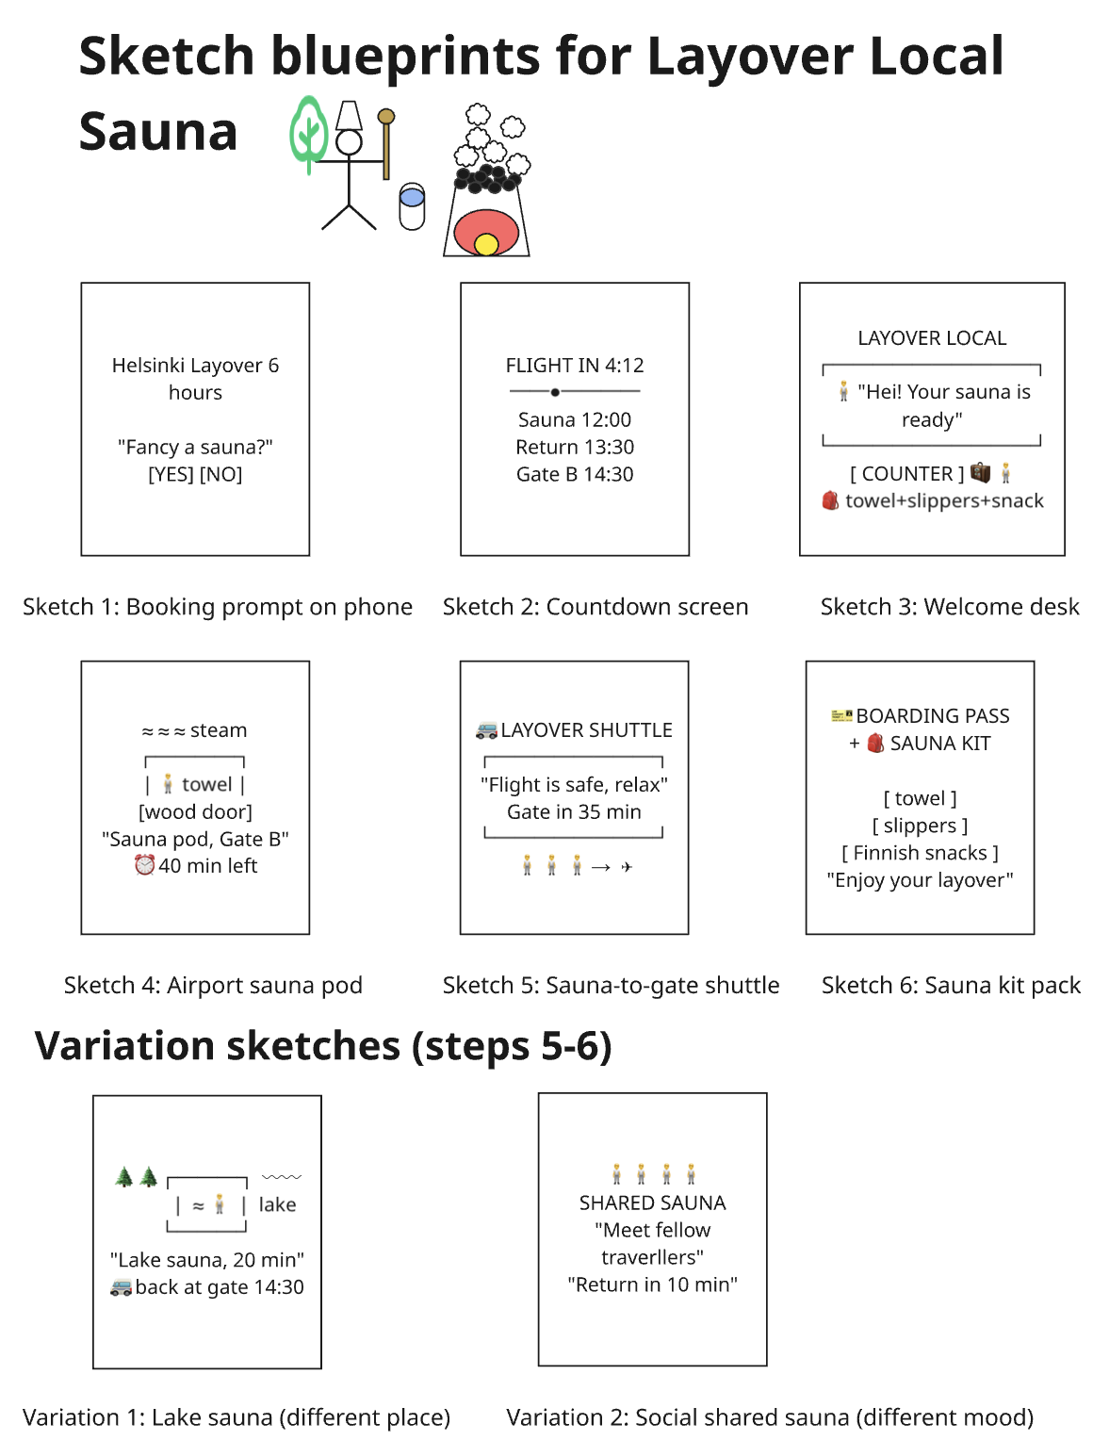

1. Value proposition
Those on long layovers become tired and nervous about missing their connecting flight. The Layover Local Sauna transforms what would have been wasted time into a relaxing experience, since all the scheduling and transportation is done for them. They chose to fly with Finnair due to the Finnish experience offered en route.

2. Core service offering
The travelers who have more than four hours of stopover time can buy the package on their Finnair app, which includes visiting the sauna (airport pod, city sauna, or lakeside sauna), a snack and towel pack, and transportation back to the gate with an ensured return guarantee.

3. Service experience promise
The travellers are at ease, taken care of, and curious. Their booking, timing, and departure back to the gate are organized for them, making the whole experience cozy and leisurely, just as if a Finnish host welcoming a guest.

4. Favourite touchpoint
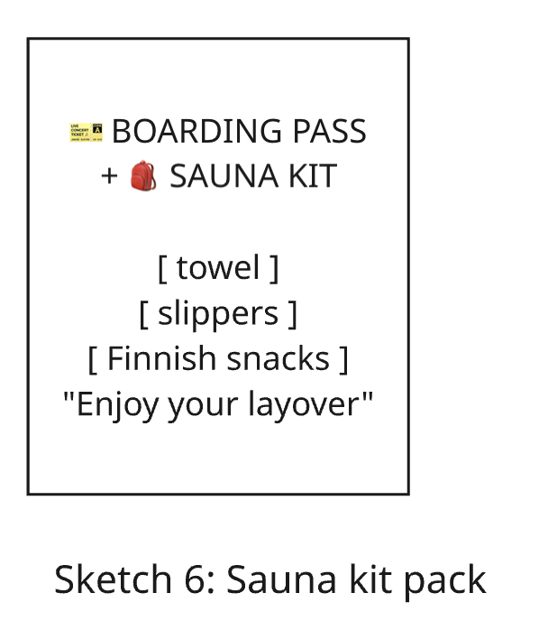
I chose the Sketch 6- Finnish sauna kit pack (towel, slippers and some Finnish snack served along with the boarding pass) as it is the only physical touch point in the almost entirely digitalized process. It proves that the company cares about the comfort of the traveler and can be used as an easy addition to the service, such as the Helsinki guide.

5. Which method did I prefer?
I liked [10+10 / normal brainstorming] more. It allowed for a lack of overthinking because of the time constraints, and doing variants opened paths that I would have never found otherwise. The latter helped define the idea initially, although it was harder to know where to stop.

6. Reflection: ideating on my own
Working alone enabled me to work quickly and maintain consistency in my concept. But then again, I lacked anyone who could give a different perspective on my concepts or tell me what sketches were good. This is something that would have happened if I worked with others.

AI Clarification
ChatGPT was used for a grammar check.

